|  |
| --- |
|  |
| Battery Powered Respirator Hood Training and Guidance. |
|  |
| Version 2.1 October 2020  All previous copies must be removed from use |
|  |

|  |  |  |
| --- | --- | --- |
| **Section** | **Title** | **Page** |
| 1 | Delivery of Training and Aims | 3 |
| 1.1 | Trainer Resources | 3 |
| 2 | Training Session Structure and Delivery | 4 |
| 2.1 | Overview of When Battery Powered Respirators are Required | 4 |
| 2.2 | Summary of How the Respirator Works | 4 |
| 3 | Pre User Checks | 5 |
| 3.1 | Demonstrate How to Assemble the Battery Powered Respirator for Use | 5 |
| 3.2 | Demonstrate How to Don and Doff the Head Piece | 6 |
| 3.3 | Quick User Guides and Link to Online Tutorial | 6 |
| 3.4 | Product User Instructions | 7 |
| 4 | Maintenance | 7 |
| 4.1 | Cumulative in Use Log | 7 |
| 4.2 | Cleaning the Respirator | 7 |
| 4.3 | Fitting & Changing of the Filter in the Power Unit | 8 |
| 4.4 | Recharging the Battery | 9 |
| 5 | Local Arrangements for the Management of the Respirators | 9 |
| 6 | Replenishment of Equipment | 10 |
| 7 | Documents to be held with Each Hood | 10 |
| 8 | Escort/Bedwatch PPE Packs | 11 |

1. **Delivery of Training Session**

Training to be delivered by the local HSF team, however in order to meet operational needs, it may be necessary for other identified staff to be trained in the delivery of the training package. Such staff must be trained by Health and Safety teams to ensure competency of delivery.

Suggested training session (30 – 45 minutes)

Identified training room to provide sufficient space to allow social distancing to be observed by those attending the session.

A signing in sheet should be completed for each session with a log, held of those who have completed the training.

**Aims**

To provide the user with information related to the Battery Powered Respirator hoods and its use during the identified tasks within HMPPS in the context of COVID 19.

To enable users to assemble, fit and use the battery powered respirator correctly.

To raise awareness to Standard Operating Procedures (SOPs) and PPE requirements and additional resources available.

To provide identified staff with information and guidance to return the respirator back into service following use; filter changes, hood cleaning and recharging of battery

**1.1 Trainer Resources**

Trainer to have access to a battery powered respirator hood to demonstrate how to assemble and discuss how to don and doff the hood.

Before running a course trainers should be familiar with;

* The current SOPs i.e. ‘bed watch/escorts, Dentistry which identify where an FFP2/3 mask or alternative battery powered respirator hood is required for Aerosol Generated Procedures (AGP).

Link to latest SOPs

<https://hmppsintranet.org.uk/except/2020/04/15/safe-operating-procedures-sop-using-ppe/>

* The Quick Start Guides, attached at point 3.3
* The User Instructions, attached at point 3.4
* It is also suggested where possible the trainer watch the online video available via the link below (under the video tab) which can be accessed on personal devices.

<https://centurionsafety.eu/product/concept-air-flip-visor-kit/>

The video is also accessible through Sphera and can be downloaded to a thick client onto the first desk top (not within 360)

Path: Library > Battery powered RPE training > Training videos.

**2. Training Session Structure and Delivery**

**2.1 Provide a brief overview of when battery powered respirators are required**

Battery powered respirators are designed so that users do not need to be face fit tested to wear them and can be used as an alternative to a FFP2/3 mask where it is identified such protection is required for AGP instances.

However like an FFP2/3 masks they must be worn and maintained correctly.

* Remind staff to ensure they are familiar with the latest  **(**SOPs) which identify where there is a requirement for an FFP2/3 mask or alternative battery powered respirator hood.

*Examples;* in the event of certain dentistry treatment involving an AGP, where an escort/bedwatch will be exposed to an AGP, during certain hospital outpatient appointments for AGP procedures such as upper gastro-intestinal endoscopy, bronchoscopy and ear, nose & throat (ENT) airway procedures that involve suctioning and respiratory tract suctioning, where there is an emergency response required to support a prisoner on Continuous Positive Airway Pressure (CPAP) treatment i.e. used for sleep apnea.

**Link to latest SOPs**

<https://hmppsintranet.org.uk/except/2020/04/15/safe-operating-procedures-sop-using-ppe/>

**2.2 Provide a brief summary of how the respirator works**

The respirator has been designed and certified to allow the electronics to manage the airflow to the wearer. When the unit is switched on, the electronics undertake an airflow check to ensure there is sufficient air to operate the unit safely.

Example

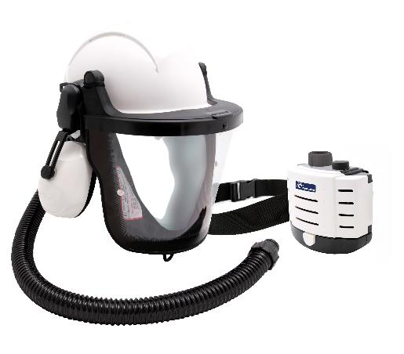

1.Contaminated Air sucked through the filter on the power unit

2.Clean, cool air flows up the hose and into the visor

3.Clean air is expelled through face seal

Airflow

* Airflow is in one direction only
* 200 l/min+ flow of clean, filtered air into the headpiece.
* Higher flow of air out of the headpiece than the wearer is breathing it keeps the wearer protected.

Virus

* Virus stays on the surface of the filter unless the filter is disturbed.

Visor

* The face/eye protection is intended to protect against impact and flying debris

**3. Pre user checks**

Discuss the importance of pre user checks to inspect the equipment for excess wear or damage, such as dents, cracks, scratches and penetration before using the respirator.

Hoods ready for use will be contained within a clear plastic bag and sealed with a tamper tag. Users should ensure the hood is in a sealed bag before taking to the point of need. If the bag/ tamper tag is not in place users should obtain a replacement respirator.

Where faults/issues as above are identified, hoods must be removed from use and reported immediately to the Orderly Officer and the identified person within Security/Ops responsible for the management of the respirators.

* 1. **Demonstrate how to assemble the battery powered respirator for use**
* Attach the battery to the power unit.
* Highlight both sides of the battery must click into place. The battery has a safety feature whereby the user needs to push both the front and rear battery release buttons to remove.
* Bring users attention to the power unit indicators/audible alarms for the air flow and Battery.
* Attach the belt to the power unit.
* Attach the hose to the power unit and headpiece.
* Highlight the user can undertake a manual check of the air flow alarm by detaching the hose from the unit and covering the outlet with their hand until the unit recognises a restriction in airflow.
* In the event either alarm activates the user should take the necessary steps to remove themselves to clean air and resolve the issue.
  1. **Demonstrate how to don and doff the head piece**

It is important to highlight for the hood to provide sufficient respiratory protection it must be fitted correctly.

* The battery powered respirator must always be donned/doffed in clean air.
* When donning/doffing the respirator, the power unit should remain turned ON for approx. 1 minute to ensure a continued supply of oxygen and to ensure continued respiratory protection.
* Before donning the head piece, users should fit assembled equipment to the waist using the supplied belt and;
* Turn on the power unit, checking air is coming out of the inner air channel at the top of the hood.
* The headpiece can be adjusted to fit using the ratchet wheel at the rear of the hood to ensure a secure, comfortable fit on the head.
* The sweatband should be sitting on the forehead and above the eyebrows for comfort.
* The D Ring attached to the shroud should be used to pull down the shroud and visor, the shroud must be in contact with the sides of the face and fit underneath the chin to provide the user with the required protection.
* Highlight any facial hair must be contained within the shroud for the hood to provide the required seal around the face as detailed above.
* For very small faces, sometimes the face seal can feel loose. Whilst the wearer is perfectly safe and protected, the face seal tension can be tightened for comfort. The face seal is attached to the headband by a Velcro attachment, which loops around the headband. To increase the tension of the elastic, pull the elastic towards the headband and shorten it and fix it in place appropriately.

**3.3 Quick user guides and online tutorial**

The attached quick start guides should be made available to attendees

** **

User may also wish to watch the online video which is available via the link below under the video tab and can be access via personal devices <https://centurionsafety.eu/product/concept-air-flip-visor-kit/>

* 1. **Product user instructions**

Attendees should be provided access to the attached instructions of use for the Powered Respirators and advised to make themselves familiar with the information.



1. **Maintenance of the Hood**

**4.1 Cumulative in use log**

Advise users that following use, the cumulative in use log held with the respirator MUST be completed before returning to the identified function e.g. Security /Ops to complete the required cleaning of the unit, recharging of the battery, checks to ensure the equipment is ready for further use. (Refer to section 5)

**4.2 Cleaning the respirator**

Following use the set should be cleaned as soon as possible in a well-ventilated area as per the TitanChlor COSHH Risk Assessment.

A Titan Chlor solution of 1000ppm (this is dependent on the tablets being either Titan Chlor or Titan Chlor plus – please refer to dilution rates on each tub or packet) should be used.

Nitrile gloves should be worn when mixing the Titan Chlor and cleaning the sets.

Respirators should be cleaned on a wipeable table or desk which is not in the direct vicinity of others to limit the risk of any surface cross contamination. If required, consider cordoning the area during the cleaning process. Following cleaning the table/desk should be wiped with the cleaning solution to remove any remaining surface contamination.

**Hood**

* The hood and visor should be wiped clean both inside and outside. It is particularly important to clean the inside of the hood and visor where the wearer has been breathing.

**Power Unit, Belt & Hose**

* The Power unit, belt & hose can be wiped clean. The battery and hose should be disconnected from the power unit before cleaning. Care must be taken to **not** get water inside the air hose, motor unit or battery connection.

**Filters**

* Filters **cannot** be wiped clean. Filters situated inside the power unit should **not** be disturbed unless being removed and disposed of. (Refer to 4.3).
* Following cleaning the respirator should be left to air dry before repacking. Where possible respirators should shelved for 72 hours before returning into use.
* Where required, a dilution of TitanChlor as above, or minimum 60% alcohol wipes should be used to clean the bag the respirator hood is stored in where this may have become contaminated either by a used hood being returned into it before cleaning or the bag has been exposed to a contaminated environment.
  1. **Fitting & changing of the filter in the power unit**
* The quick start guide provides pictorial information of the filter location within the power unit. (Refer to 3.3)
* 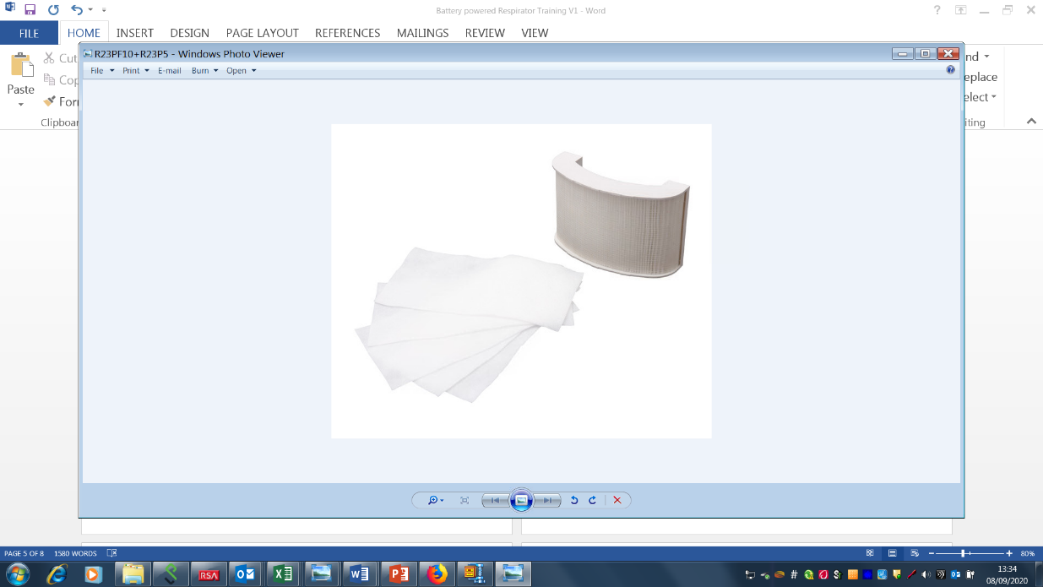The respirator has two filters, for COVID 19 protection only the main filter is required to be fitted to provide users the necessary respiratory protection, the optional Pre filter is not required.

**Main filter**

**Pre filter (**not required)

* Note, if the respirator is used for an alternative purpose i.e. in an industrial environment the 2nd pre filter may be required depending on the hazard present.
* Filters will provide respiratory protection for a maximum of 24 hours and should be changed when this cumulative time has been reached**.** (see section 5.0)
* Restate, the audible alarm will sound where the filter and or air pipe becomes blocked, this can indicate the filter needs to be changed.
* Discuss that when changing the filter there is a risk of viral contamination and the person changing the filter MUST wear the appropriate PPE; Surgical Mask (FRSM), apron, nitrile gloves, and follow good hand hygiene.
* When changing the filter the power unit should be decontaminated before removing the filter. The power unit should be positioned so that the filters are facing downward, ensuring any trapped particulate material released by removing the filter does not fall into the filter port.
* Filters should not be used after their expiry date displayed on the packaging, the sealed bag containing the filter shouldn’t be opened until you are ready to use it.
* The used filter and PPE should be disposed of into a clinical waste bag.

**4.4 Recharging the battery**

* Battery life approx. 8 hours, restate the audible alarm will sound if the battery is low and needs to be changed.
* Charging takes approx. 6 hours.
* The LED on top of the charger will illuminate red to indicate the battery is charging and will change to constant GREEN when the battery is fully charged.
* It is recommended batteries are not connected to the power unit during charging

1. **Local Arrangements for the Management of the Respirators**

* The respirators are to be managed by a responsible person within Security/Ops with the responsibility to manage each respirator on site.
* The respirators must be kept in a suitable location within Security / Ops.
* All new sets must be commissioned into use by security with support from HSF teams
* A master asset register with unique I.D number allocated to each set must be created and held for all respirator on site.
* A cumulative in use log must be held with each respirator and must be completed by the user to record cumulative in-use time for each respirator.



* A master log for each respirator unique I.D number must be held centrally in Security/ Ops and updated with the in- use cumulative data following each use of the respirator and following battery change, each clean and filter change to record the necessary management arrangement.



* Respirators must be appropriately cleaned following each use and where possible not returned into circulation for 72 hours following use/cleaning. (Refer to 4.2)
* Respirator main filter must be changed when the in-use cumulative time (24 hours) is reached. (Refer to 4.3)
* Both the cumulative in use log and master record log must be updated to record the filter change.
* Following each use the battery must be recharged (Refer to 4.4)
* The hood should be checked for general wear and tear/damage following use. Where faults are identified hoods should be removed from use.
* Hoods must be repacked into a clear disposable bag and sealed using a security tamper tag following cleaning & recharging **BEFORE** being returned to the Hi Vis bag supplied and returned to their identified location for further use. ( Also see section 6)
* A functionality test should be undertaken monthly by an identified person within security with auditable records held for scrutiny.
* Management checks to be completed monthly by the identified person within Security/Ops with auditable records held for scrutiny.

**6. Replenishment of Equipment**

**Note;** an initial supply of plastic bags will be supplied with the respirators, further orders should be ordered via SOP.

* **Clear disposable bags** (465x600mm) – order via SOP - Code CH1000751 (box of 250) from Greenhams.
* **Tamper tags** - order via SOP - Code SY8000000 (pack of 1000) from Scene safe.
* **Spare Parts/batteries** – should be requested via Non Cat request



* **Replacement filters** - Order via the PPE Hub
* **Purchase of further Battery Powered Respirators (BR**-**RPE) -** if required should be requested via the Principle HSF service lead in the first instance who will assess the need through RA for the procurement of further sets through Non Cat request.
* **Hi-Vis Holdall (**supplied with each Respirator); Replacements can be ordered via SOP - Code 476102 from Arco



**7. Documents to be held with each hood**

A copy of the attached documents, should to be contained within zipped pocket of the Hi Vis bag and checked following each use and replaced where missing.



**8. Escort/Bedwatch PPE Packs**

Escort and bedwatch packs can also be included into the Hi Vis bag, following use, the PPE used from the pack MUST be replenished. Details of pack contents are located in the Escort/Bedwatch SOP

<https://hmppsintranet.org.uk/except/2020/04/15/safe-operating-procedures-sop-using-ppe/>